# Plot of Events’ PSD in function of time for each electrode

# /Users/kientzelise/Downloads/WhatsApp Image 2018-04-25 at 17.24.53.jpeg

To get these figures we average the PSD values of each events (both feet and both hands). The repartition of electrodes on the 16-electrods cap is as follow:

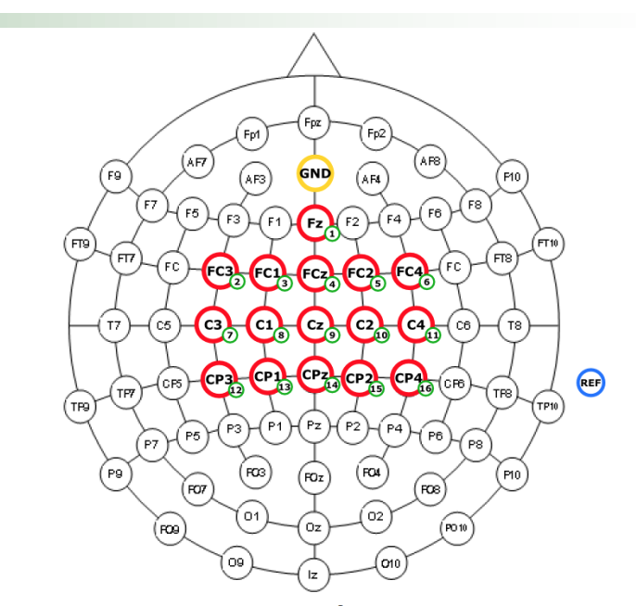

As we know that motor cortex for hands movement planning is situated on lateral sides of the brain, we expect to see a differentiation in the PSD behavior for Event “Both Hands” in Electrodes 7 or 11. For a feet movement planning, we expect to see changes in Electrode 9.

On this figure we represented the PSD for both hands (BH) and both feet (BF) events from the fixation event to the end of the continuous feedback event. We represented the end of the Fixation event by a vertical green dashed line which gives a “start” for the movement planning.

Indeed, we see that for electrode 7 a net distinction can be made between BF and BH events as the data corresponding to the BH events decrease “considerably” compared to data corresponding to the BF events. As we know, a decrease in PSD value corresponds to a desyncronisation of the cortex neurons.

We can see the same phenomenon in Electrode 11, with less separability than for Electrode 7.

In electrode 9, we do not see any difference between BF and BH events.

Electrode 8 and Electrode 10, which are near to the motor cortex area for BH event planning also show a desynchronization for BH event.

The only electrode that shows a desynchronization for BF event is the Electrode 14. Its position, near to the one predicted to be relevant for BF event detection (Electrode 9) can in parts attests the planning of a BF event rather than a BH event.

For future steps, these figures can help us determining which electrode is useful to classify our event. If we focus for example on electrode 7, 11 and 8 : we could determine if the measured signal corresponds to a BF or a BH event planning.